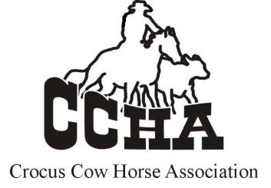
SHOW ENTRY FORM

SHOW DATE: _______________
Only one horse/rider per entry form, please
RIDER NAME: _______________________________________
HORSE COUNCIL # ______________ HORSE NAME:________________________________
OWNER NAME: ______________________________________________________________

EMAIL ADDRESS: _____________________________________________________________
PHONE NUMBER: ________________ MAILING ADDRESS: __________________________
DIVISIONS
(Check all divisions you are entering. All fees must be paid for each division.)
OPEN NON-PRO NON-PRO LIMIT 3-4 YEAR OLD NOVICE HORSE
YOUTH YOUTH LIMIT BUCKAROO COVID CATCH UP
CLASSES
(Check all you are entering)
HERD WORK |  | COW WORK |  | REINED WORK
FEES:
HERD WORK (cattle charges must be paid for each division entered)
CATTLE FEE (This includes the Working Cow Fee) (per division) |  | $100.00
JUDGING FEE (per class, per division) |  | $10.00
COW WORK
CATTLE FEE (if entering working cow ONLY) |  | $35.00
JUDGING FEE (per class, per division) |  | $10.00
REINED WORK
JUDGING FEE (per class, per division) |  | $10.00
OFFICE FEES (not required for buckaroo division)
Non-Member Fee (per division) |  | $15.00
BUCKAROO (no cattle fee required)
CLASS FEE & JUDGING FEE |  | $25.00
 | TOTAL FEES

PLEASE PRINT OR SCAN AND EMAIL TO: crocuscowhorse@gmail.com
Marsha Boese Cell Phone 204-647-237
ENTRIES CLOSE AT MIDNIGHT THE TUESDAY BEFORE EACH SHOW

Office Use Only
Cheque #____ Cash
Amount Pd $_________

Entries must be paid before entering the show ring. $25 late fee and you will run last on used cattle.

