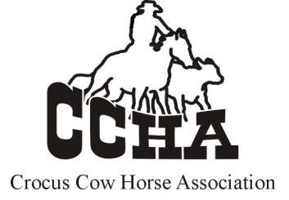SHOW ENTRY FORM

# SHOW DATE: ______________________

RIDER NAME: _____________________________ OWNER NAME: ____________________________

HORSE COUNCIL # or EQUIVILENT _______________ PHONE NUMBER: __________________________

## HORSE NAME:_______________________________ EMAIL ADDRESS: ___________________________

MAILING ADDRESS: ________________________________________________________________________

|  |  |  |  |  |
| --- | --- | --- | --- | --- |
|  | **DIVISIONS**  **(Check all divisions you are entering. All fees must be paid for each division.)** | | | |
|  | **OPEN NON-PRO NON-PRO LIMIT 3-4 YEAR OLD NOVICE HORSE**  **YOUTH YOUTH LIMIT OPEN REIN/BOX BUCKAROO** | | | |
|  | | **CLASSES**  **(Check all you are entering)** |  |  |
| **HERD WORK** | | **COW WORK** |  | **REINED WORK** |

**FEES:**

|  |  |  |  |  |
| --- | --- | --- | --- | --- |
| **HERD WORK** (cattle charges must be paid for each division entered) | |  | | |
| CATTLE FEE (This includes the Working Cow Fee) (per division) | | $125.00 |  | |
| JUDGING FEE (per class, per division) | | $15.00 |  | |
| Jackpot (must pay above CCHA class fees) | | $20.00 |  | |
| **REINED WORK** | |  | | |
| JUDGING FEE (per class, per division) | | $15.00 |  | |
| JACKPOT (must pay above CCHA fees) | | $20.00 |  | |
| **COW WORK** | |  | | |
| CATTLE FEE (if entering working cow ONLY) | | $50.00 |  | |
| JUDGING FEE (per class, per division) | | $15.00 |  | |
| **OFFICE FEES** (not required for buckaroo division) | |  | | |
| Non-Member Fee (per division) | | $15.00 |  | |
| **BUCKAROO** (no cattle fee required) | |  | | |
| CLASS FEE & JUDGING FEE | | $25.00 |  | |
| **TOTAL FEES** | | |  | |

## Please email completed entry for to: [crocuscowhorse@gmail.com](mailto:crocuscowhorse@gmail.com)

**ENTRIES CLOSE AT MIDNIGHT THE TUESDAY BEFORE EACH SHOW NO REFUNDS AFTER THIS DATE**

**E-transfers Encouraged to** [crocuscowhorse@gmail.com](mailto:crocuscowhorse@gmail.com)

Entries must be paid before entering the show ring. $25 late fee and you will run last on used cattle

**CCHA President – Shannon McKenzie** **Cell Phone:** **204-761-2147**